**ASSIGNMENT 02 FRONT SHEET**

|  |  |  |  |
| --- | --- | --- | --- |
| **Qualification** | **BTEC Level 5 HND Diploma in Computing** | | |
| **Unit number and title** | Unit 09: Software Development Life Cycle | | |
| **Submission date** | 20th October 2022 | **Date Received 1st submission** |  |
| **Re-submission Date** |  | **Date Received 2nd submission** |  |
| **Student Name** |  | **Student ID** |  |
| **Class** | GCH1005 | **Assessor name** | Michael Omar |
| **Student declaration**  I certify that the assignment submission is entirely my own work and I fully understand the consequences of plagiarism. I understand that making a false declaration is a form of malpractice. | | | |
|  |  | **Student’s signature** |  |

**Grading grid**

|  |  |  |  |  |  |  |  |  |
| --- | --- | --- | --- | --- | --- | --- | --- | --- |
| P5 | P6 | P7 | M3 | M4 | M5 | M6 | D3 | D4 |
|  |  |  |  |  |  |  |  |  |

|  |  |  |
| --- | --- | --- |
| **❒ Summative Feedback: ❒ Resubmission Feedback:** | | |
| **Grade:** | **Assessor Signature:** | **Date:** |
| **Internal Verifier’s Comments:** | | |
| **Signature & Date:** | | |

# Table of contents

Table of contents 1

List of figures 2

List of tables 2

Introduction 2

P5 Undertake a software investigation to meet a business need 2

- The stakeholders, their roles, and their interests in the report. 2

- A review of the project's requirement specification which stakeholders were responsible for which requirements. 2

- The relationship between FRs and NFRs. 2

- The requirement traceability matrix discussion in the report. 2

- Discuss the approach/technique (es) you'd take to obtain the requirements 2

P6 Use appropriate software analysis tools/techniques to carry out a software investigation and create supporting documentation. 3

- Analyze the requirements that you identified in Task 1 using a combination of structural and behavioral modelling techniques that you have learnt. 3

Use Case Diagram for the whole system. 3

Use Case specification for 2 Use cases. 3

Context Diagram for the whole system. 3

Data Flow Diagram – Level 0 for the whole system. 3

ERD for the whole system. 3

Pseudocode 3

Flowchart 3

P7 Explain how user and software requirements have been addressed. 3

Provide the mockup or wireframe (at least 5) designs of the Tune Source project to justify that it matches users’ requirements. 3

Design architecture (for example a three-tiered) selection. 3

An explanation of why the chosen architecture is suitable for this project. 3

Provide the technical solution stack suitable to implement the project. 3

You have to discuss two software quality attributes that are applicable to the project 3

You should give the QA techniques to help improve the software quality in the project 3

Discuss how the design techniques and approaches that you have used can help improve the software quality 3

Conclusion 4

References 4

# List of figures

# List of tables

# Introduction

# P5 Undertake a software investigation to meet a business need

## The stakeholders, their roles, and their interests in the report.

|  |  |  |  |
| --- | --- | --- | --- |
| **Stakeholders** | **Roles** | **Interest** | **Note** |
| Carly Edwards | Assistant Vice President, Marketing | Is to create an increase in sales by creating the capability of selling digital music downloads to customers through kiosks in stores, and over the Internet using the new website |  |
|  |  |  |  |
|  |  |  |  |

Table : List of stakeholders and roles

## A review of the project's requirement specification which stakeholders were responsible for which requirements.

|  |  |  |
| --- | --- | --- |
| **High level requirement specification** | **Responsible stakeholder** |  |
|  |  |  |
|  |  |  |

Table : Requirement specification with responsible stakeholder

## The relationship between FRs and NFRs.

|  |  |  |
| --- | --- | --- |
| **Functional requirements FRs** | **Non-functional requirement NFRs** |  |
|  |  |  |

Table : Relationship between functional and non-functional requirements

## The requirement traceability matrix discussion in the report.

## Discuss the approach/technique (es) you'd take to obtain the requirements

# P6 Use appropriate software analysis tools/techniques to carry out a software investigation and create supporting documentation.

## Analyze the requirements that you identified in Task 1 using a combination of structural and behavioral modelling techniques that you have learnt.

### Use Case Diagram for the whole system.

### Use Case specification for 2 Use cases.

### Context Diagram for the whole system.

### Data Flow Diagram – Level 0 for the whole system.

### ERD for the whole system.

### Pseudocode

### Flowchart

For each diagram, you will have to explain properly.

# P7 Explain how user and software requirements have been addressed.

### Provide the mockup or wireframe (at least 5) designs of the Tune Source project to justify that it matches users’ requirements.

### Design architecture (for example a three-tiered) selection.

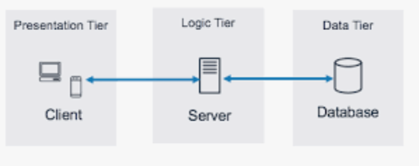

Figure : Example Three tier - Design architecture for TN source project

### An explanation of why the chosen architecture is suitable for this project.

### Provide the technical solution stack suitable to implement the project.

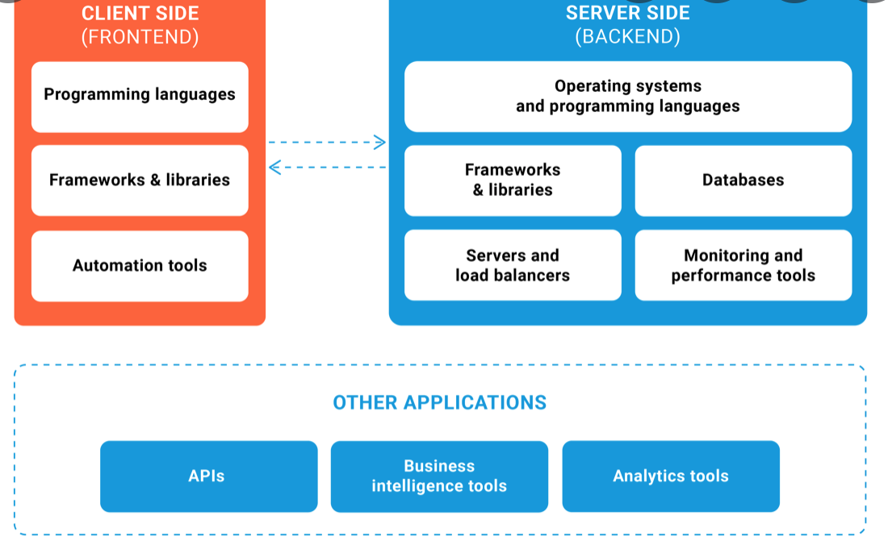

Figure : Example Technical solution stack for TN Source project

### You have to discuss two software quality attributes that are applicable to the project

### You should give the QA techniques to help improve the software quality in the project

### Discuss how the design techniques and approaches that you have used can help improve the software quality

# Conclusion

# References